Microbiology · Exam 2 — Study Guide
Editable Word copy of the PA_Quizzes study aid. Headings use real Word styles, so the navigation pane and the contents field below both work, and restyling one heading restyles them all.
[In Word: right-click here and choose Update Field to build the contents.]

7 · Disorders in Immunity
INSTRUCTIONAL OBJECTIVES
- Describe the types of immunopathologies.
- Compare and contrast the types of hypersensitivities and diseases caused by hypersensitivity conditions.
- Describe the primary methods of diagnosing, treating, and preventing allergies.
- Describe the mechanism of transfusion reactions.
- Explain the immunology of transplantations and tissue histocompatibility.
- Describe etiology autoimmune conditions.
- Differentiate between primary and secondary immunodeficiency conditions.
- Explain the mechanisms of carcinogenesis.
- Compare and contrast immunotherapy strategies.

NOTE
One table organizes most of this lecture. The four hypersensitivities differ by effector mechanism, and nearly everything later in the deck is one of them applied somewhere new: transfusion reactions are type II, the three speeds of transplant rejection are types II, IV and III, and autoimmunity uses every type except I. Learn the table in 7.2 first and the rest of the lecture places itself.

★ PROFESSOR EMPHASIS
★ From the lecture recording — 18 September 2026
About 97 minutes with Dr. Webster, in two parts. Both transcripts read and compared (Notability’s own and an independent local transcription); every quote below appears in both, with the same wording and timing. Every factual claim was checked against the deck, and where the two differ the slide is what this guide teaches.
Unlike Lecture 1, this lecture signposts. It names one chart to learn, one mechanism that matters most, one pairing she said outright you need to know, and six slides not to memorize.
What was said | What it means for you
“This is actually a chart you should pay attention to because it is a very good summary chart of the four different types of hypersensitivities.” [part 1, 10:14] | Slide 9, the four-types table. It is reproduced in 7.2 and is the spine of the lecture.
“The most important thing I want you to remember about this is making the IgG [immunoglobulin G] antibodies, which can block the reaction.” [part 1, 34:23] | Desensitization (slides 29–30). The regulatory T cell effects are real, but the blocking immunoglobulin G is the headline.
“Please note there’s no type 1 at all.” [part 2, 13:13] — and of autoimmunity, “type one is not involved in either of these.” [part 2, 21:50] | Type I plays no part in graft rejection or in autoimmunity. Both lists run II, III and IV.
“B cell defect is agammaglobulinemia… this we associate with more bacterial infections. And yes, you need to know that. That’s why it is bold and italicized.” [part 2, 32:34] She repeated the pairing a minute and a half later: “remember the T cell deficiency, you get more of fungal, viral, protozoan infections; B cell deficiency, more of the bacterial infections.” [part 2, 34:12] | B cell deficiency → recurrent bacterial infections; T cell deficiency → fungal, viral and protozoan (slides 63–64). The only thing in the lecture said twice and called “need to know”.
“This is not a chart you need to memorize.” [part 1, 4:07] | Slide 6, the helminth antigen ↔ allergen pairings. Know the principle (allergens resemble parasite antigens), not the pairs.
“You don’t need to memorize this chart.” [part 2, 19:57] | Slide 50, the four grades of graft versus host disease. Know what the disease is and that it affects about 30% of marrow recipients.
“Charts I do not want you to memorize… no, you do not need to memorize those charts.” [part 2, 29:48–30:11] | Slides 58–60, the type II, III and IV autoimmune disease tables. The diseases you are expected to know are the ones slide 61 writes out: Graves’, Hashimoto’s, type 1 diabetes, myasthenia gravis, multiple sclerosis.
“The process of transformation… I’m not going to ask you to memorize the sequence.” [part 2, 37:03] | Slide 67’s stepwise colon-cancer figure. Know that a cancer is one cell with accumulated mutations, not the order of the genes lost.
Oncogenic viruses: “we will talk about the papilloma virus… hepatitis B and Epstein-Barr when you have my lecture on DNA [deoxyribonucleic acid] viruses. Dr. Fair will talk about… the human T cell leukemia virus as well as HIV [human immunodeficiency virus] and some herpes viruses.” [part 2, 39:27–39:45] | Slide 68 is deferred to the virus lectures. Here, know that viruses are one route to oncogene activation, and the two that slide 81 names for prevention.

Things said that are not on a slide — consistent with the deck, useful as hooks, and each present in both transcripts:
- Immunoglobulin G is the only antibody that crosses the placenta, which is why a sensitized Rh-negative mother’s next Rh-positive baby is the one at risk. [part 1, 43:22]
- The tuberculin skin test is read at 48 to 72 hours, and once positive it stays positive because of memory cells. [part 2, 4:19]
- Poison ivy oil binds the skin within about 15 minutes (wash it off before then), and the first exposure takes 7 to 10 days to make effector T cells — by which time the exposed skin has shed, so the first contact produces no rash. [part 2, 5:32–6:22]
- Blood type O is the universal donor (no A or B antigen on the cell); AB is the universal recipient (no anti-A or anti-B antibody in the serum). [part 1, 38:19–39:20]
- Bone marrow donors are matched on at least 10 human leukocyte antigen markers, and even that is not always enough to prevent graft versus host disease. [part 2, 18:43]
- “Nobody actually dies of HIV [human immunodeficiency virus]. They die of the things you catch because of the suppressed immune system.” [part 2, 35:30]
Two slips to ignore, both now heard in both transcripts, so they are what was said rather than transcription errors. She opens part 2 by calling immune complexes “a type 2 reaction” [part 2, 0:07], straight after closing part 1 with “before we start with type three”; slide 38 says type III, and it is type III. And she calls allergy “IgA mediated” [part 1, 25:47] in the late-phase sentence, then says “those new IgE” eight seconds later; slide 23 says immunoglobulin E. (IgE and IgA sound alike, so a shared mishearing cannot be ruled out; either way the answer is IgE.) Go by the slides.

7.1 · Objective 1 — The four immunopathologies
Immunopathology | What it is | Direction
Allergy / hypersensitivity | An exaggerated, misdirected expression of immune responses to an allergen (antigen). Uses the same mechanisms as protective immunity. Four types: I, II, III are B cell mediated; IV is T cell mediated | Overreaction
Autoimmunity | Abnormal responses to self antigens | Typically overreaction
Immunodeficiency | Deficiency or loss of immunity | Underreaction
Cancer | Both a cause and an effect of immune dysfunction | Underreaction

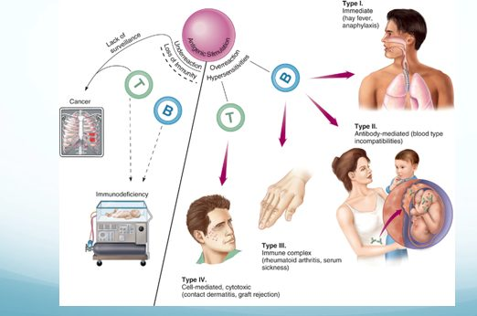
The whole lecture on one page. Read it as a fork at the top: overreaction on the right splits into the four hypersensitivities by the cell that drives them (B cell arrows to types I, II and III; the T cell arrow to type IV), while underreaction on the left leads to immunodeficiency and, through lack of surveillance, to cancer. Type II’s example is a mother and fetus because Rh incompatibility is a type II reaction. Source: Lecture 7 Dr. Webster Disorders in Immunity.pptx, Slide 4.
Also tested
- Cancer and immune dysfunction. Cancer is both a cause and an effect: immune failure permits it, and the tumor then suppresses immunity. Immune surveillance normally keeps cancer in check, and successful tumors evade and actively manipulate the response once established.
- Four immunopathologies. The four categories are allergy, autoimmunity, immunodeficiency and cancer; allergy and autoimmunity are overreactions, while immunodeficiency and cancer are underreactions.

7.2 · Objective 2 — The four hypersensitivities and their diseases
Also tested
- Arthus reaction. It is localized dermal injury from inflamed blood vessels, a vasculitis typically following a second injection of vaccine at a site, and normally self limiting.

The cells shared by defense and allergy
Cell | Where / what | Defensive role
Mast cells | On epithelial surfaces; immunoglobulin E on the surface; filled with cytokine granules | —
Eosinophils | Granulocytes that release toxic mediators in an immunoglobulin E response | Eukaryotic parasites
Basophils | Rare granulocytes that initiate a type 2 helper T cell response and production of immunoglobulin E | Helminths

The hygiene hypothesis. Many allergens resemble parasitic antigens, and helminth infection (about 1 billion people heavily and persistently infected) produces exactly the allergic profile — CD4 type 2 helper T responses, high immunoglobulin E, more eosinophils and mast cells — yet no allergic disease. Why: nonspecific immunoglobulin E competes for the Fc receptors on mast cells, basophils and activated eosinophils, and regulatory T cells suppress T cell responses in chronic parasitic infection. Where helminths were eradicated (Western Europe, North America) by better hygiene, vaccination and antibiotics, the immune system is underused and less successfully regulated.
Predisposition. A generalized predisposition to allergy is familial — not a predisposition to a specific allergy. Allergy is affected by age, infection and geographic area; atopic allergies may be lifelong, outgrown, or develop later in life. The four groups are defined by the effector mechanism, and the reaction can differ with the mechanism of exposure.
★ PROFESSOR EMPHASIS
★ Professor emphasized — “a chart you should pay attention to”
Type | Mechanism | Examples
I  Immediate | Immunoglobulin E mediated. Cell-bound antibody is crosslinked and releases inflammatory mediators; mast cells, basophils and eosinophils involved | Hay fever, hives, anaphylactic shock
II | Initiated by immunoglobulin G and M. Free antibody binds cell surface antigens; complement activated; cell lysis by the membrane attack complex and phagocytosis | Transfusion reactions
III | Initiated by immunoglobulin G and M. Free antibody binds soluble antigens forming immune complexes, which embed in basement membranes and start inflammation (phagocytosis and complement) | Serum sickness; autoimmune conditions such as lupus
IV  Delayed | T cell mediated. Cytotoxic cells destroy tissue | Contact dermatitis

Allergens and the type I mechanism
Allergens are immunogenic: proteins, or lower molecular weight haptens. They typically enter through epithelial portals — respiratory, gastrointestinal, skin — and the organ where the allergy shows may or may not be the portal of entry.
Dose | What happens
Sensitizing dose (first contact) | Specific B cells form immunoglobulin E, which attaches to mast cells and basophils. Generally no signs or symptoms.
Provocative dose (later contact) | The same allergen binds the immunoglobulin E on the mast cell (each cell binds 10,000–40,000 immunoglobulin E); mast cells degranulate, releasing inflammatory cytokines.

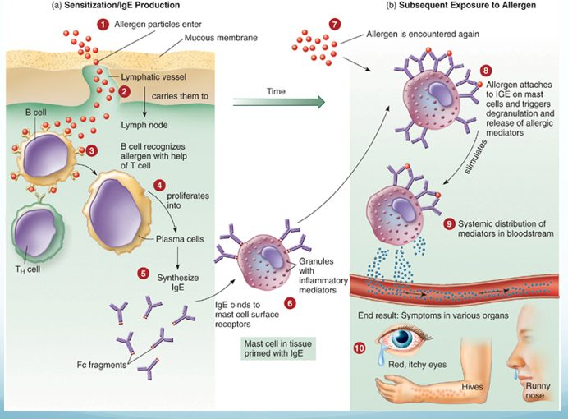
Two exposures, two panels. On the left nothing visible happens: the allergen is carried to a lymph node, plasma cells make immunoglobulin E, and it parks on mast cells (step 6) — which is why the sensitizing dose produces no symptoms. On the right the same allergen bridges the bound antibody (step 8) and the mast cell empties its granules into the blood, so the symptoms appear in organs far from where the allergen entered. Source: Lecture 7 Dr. Webster Disorders in Immunity.pptx, Slide 13.
General targets are the skin, upper respiratory tract, gastrointestinal tract and conjunctiva (rashes, itching, redness, rhinitis, sneezing, diarrhea, tears); systemic targets are smooth muscle, mucous glands and nervous tissue (vascular dilation and constriction changing blood pressure and respiration).
Manifestation | Mechanism
Urticaria (hives) | Mast cells in the skin release histamine → raised, itchy swelling
Angioedema | Activation of mast cells deeper in the skin
Atopic dermatitis (eczema) | A more prolonged allergic response in the skin
Allergic rhinitis (hay fever) | Inhaled allergen; histamine raises capillary permeability and nasal mucus; eosinophils are attracted from blood, release mediators and are shed into the nasal passage
Food allergy | Vomiting, diarrhea and urticaria. Local histamine acts on intestinal epithelium, vessels and smooth muscle; urticaria appears because antigen enters blood vessels and is carried to the skin
Allergic asthma | Acute: bronchial smooth muscle contraction, more mucus, airway obstruction. Leads to chronic asthma, which is type IV, mediated by cytokines and eosinophil granules

Anaphylaxis
Cutaneous anaphylaxis is the wheal and flare skin reaction — the one used in allergy diagnosis. Systemic anaphylaxis is sudden respiratory and circulatory disruption that can be fatal in minutes. Allergen and route vary: bee stings, antibiotics and serum by injection; foods such as peanuts by mouth. The allergen reaches the bloodstream and activates connective tissue mast cells around blood vessels throughout the body. Fluid leaves the blood → drastic fall in blood pressure → tissue swelling → organ damage → death by asphyxiation from constricted airways; 500–1000 deaths a year in the United States.
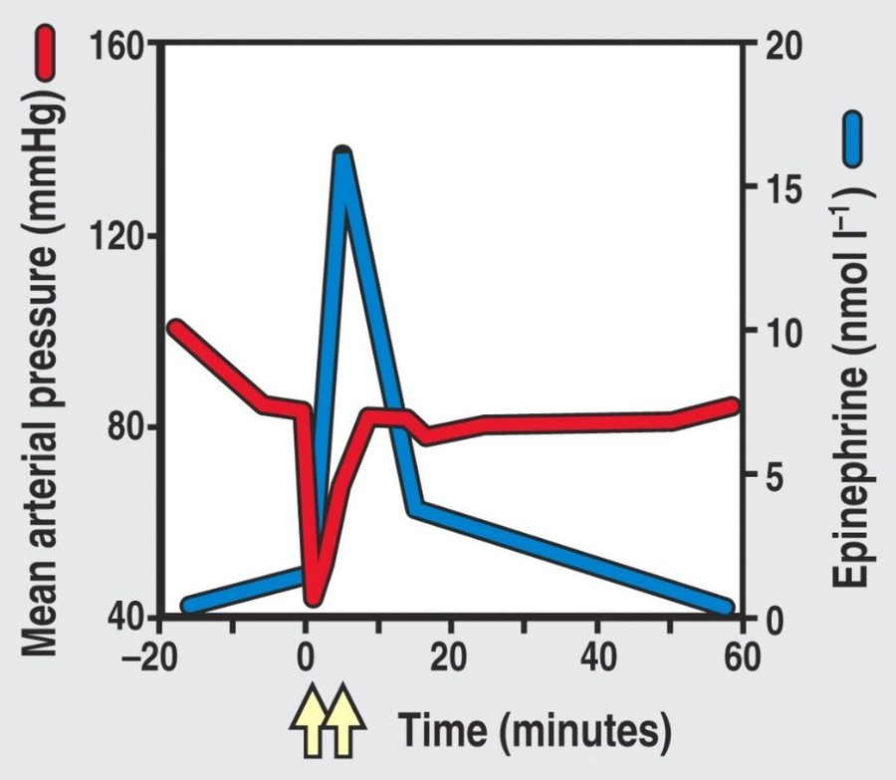
Read the two lines against each other. The red mean arterial pressure line falls off a cliff at time zero — fluid leaving the vessels — and the yellow arrows mark the epinephrine doses. Pressure climbs back only as the blue epinephrine line spikes, which is the curve’s whole point: epinephrine is what reverses the collapse, by resealing endothelial tight junctions and stimulating the heart. Source: Lecture 7 Dr. Webster Disorders in Immunity.pptx, Slide 22.
What epinephrine does in anaphylaxis (five actions): stimulates reformation of endothelial tight junctions; relaxes bronchial smooth muscle; prevents or decreases upper airway mucosal edema; stimulates the heart; binds receptors on immune cells to suppress histamine release.
Late phase reaction. Immunoglobulin E reactions have an immediate response (the wheal and flare, from mast cell degranulation) followed about 6 hours later by a late phase reaction mediated by synthesized products such as leukotrienes. It attracts more cells, including eosinophils, whose cytokines enhance inflammation and make the tissue more sensitive next time. In asthma, measured as forced expiratory volume in 1 second, the immediate response is under 1 hour and the late phase response over 6 hours.

Types II, III and IV and their diseases
Type | Key features | Diseases
II | Lyses foreign cells; immunoglobulin G or M; stimulates complement | Transfusion reactions (ABO); Rh factor — hemolytic disease of the newborn; some autoimmune: autoimmune hemolytic anemia, myasthenia gravis (acetylcholine receptors)
III | Immunoglobulin G and M (sometimes A) with complement; complexes deposit in basement membranes of epithelial tissues; needs a large amount of antigen; symptoms delayed hours to days; joints, skin and kidney typical | Serum sickness (foreign animal proteins — horse serum for tetanus, animal hormones or drugs; complexes in heart, kidneys, skin, joints). Arthus reaction (localized dermal vasculitis after a second vaccine injection at one site; self-limiting). Autoimmune: post-streptococcal glomerulonephritis, systemic lupus erythematosus, rheumatoid arthritis
IV | Delayed; T cell mediated; activation of and damage by T cells | Infectious allergy (tuberculosis, leprosy, syphilis, histoplasmosis, toxoplasmosis, candidiasis); tuberculin skin test; contact dermatitis from plants, metals, cosmetics; graft rejection

Contact dermatitis follows the same two-dose logic as type I, but with T cells: first contact is the sensitizing dose; later contact is the reactive dose, with tissue damage from macrophage cytokines and cytotoxic T cells.

7.3 · Objective 3 — Diagnosing, treating and preventing allergies
First decide whether the patient has allergy or infection. Then:
Test | Use
Skin testing — skin prick, intradermal | Reads wheal and flare reactions
Blood tests | Specific immunoglobulin E; increased basophils
Physician-supervised challenge | Food allergy when other tests are inconclusive
Patch test | Contact dermatitis (type IV)

Management of type I hypersensitivity has three general methods: prevention, pharmacological control and desensitization. Prevention means modifying the environment and behaviors to avoid the allergen.
Drug | Action
Corticosteroids | Inhibit lymphocytes to reduce immunoglobulin E
Cromolyn sodium | Blocks mast cell degranulation
Montelukast sodium | Blocks leukotriene synthesis
Omalizumab | Monoclonal antibody against immunoglobulin E
Antihistamines | Bind histamine receptors on target organs
Epinephrine | Reverses airway constriction; re-establishes endothelial tight junctions

★ PROFESSOR EMPHASIS
★ Professor emphasized — “the most important thing”
Desensitization (allergen-specific immunotherapy). The most common form is subcutaneous immunotherapy: small amounts of allergen by injection. The injected allergen stimulates high levels of allergen-specific immunoglobulin G that blocks the allergen from reaching the immunoglobulin E, so mast cells do not degranulate. It improves reactions in about 80% of those who complete it.

“Of course it’s not that simple”: desensitization also activates regulatory T cells, which inhibit T cell activation of B cells and release anti-inflammatory cytokines, and induces mediators that damp T cell proliferation and mast cell and eosinophil activity. Sublingual immunotherapy places allergen under the tongue as a tablet or liquid; it is used more elsewhere than in the United States (which has tablets for pollen and dust mite). A 4-year trial of a peanut dose equal to 1/75 of a kernel was effective and safe, protecting against accidental exposure; it has also worked for kiwi, hazelnut, milk and peach.

7.4 · Objective 4 — The mechanism of transfusion reactions
A transfusion reaction is type II. Donor and recipient are matched for the ABO blood group antigens because red blood cells carry no major histocompatibility complex molecules — ABO is what the immune system sees. You carry antibodies in your serum against the ABO antigens you lack. Transfusions are temporary, and an ABO incompatibility can be fatal through complement activation and cell lysis.
Step | Detail
Cross-match | Recipient’s serum against donor’s red cells. Not the reverse: even whole blood carries too little donor antibody to coat the recipient’s cells densely enough to react
Consequences | Red cell destruction → blocked glomeruli, fever, jaundice. Even incomplete complement activation leaves antibody-coated cells for natural killer cells and macrophages

NOTE
Rh factor and hemolytic disease of the newborn (erythroblastosis fetalis). Rh antigen is on Rh-positive cells only. An Rh-negative person makes no anti-Rh antibody unless sensitized — by a bad transfusion or an incompatible pregnancy (Rh-negative mother, Rh-positive fetus). The first pregnancy is normally fine; it sensitizes. Later pregnancies may be hemolytic. Prevention is passive immunization with antibody against the Rh antigen (Rhogam), which prevents sensitization of the mother. Give it at 26–28 weeks, within 72 hours after birth, and after prenatal invasive tests, abdominal injury or accidental exposure.

7.5 · Objective 5 — The immunology of transplantation and tissue histocompatibility
Rejection runs both ways — the host may reject the graft, and the graft may reject the host — and it is governed by the major histocompatibility complex: different grafts succeed to different degrees because of its compatibility.
Graft | Source
Autograft | Self (skin, gum or vein graft)
Isograft | Genetically identical twin
Allograft | Another member of the same species
Xenograft | Another species

★ PROFESSOR EMPHASIS
★ Professor emphasized — “there’s no type 1 at all”
Solid organ problem | Type | Mechanism
Hyperacute rejection | II | Preexisting antibody against graft antigens; the graft becomes engorged and purple from hemorrhage and fails
Acute rejection | IV | Effector T cells respond to human leukocyte antigen differences between donor and recipient
Chronic rejection | III | Months or years later; immune complexes in the graft’s vessel walls thicken them until blood supply fails. Causes failure of more than half of kidney and heart transplants after 10 years or more
Graft versus host disease | IV | Donor cells attack host tissue

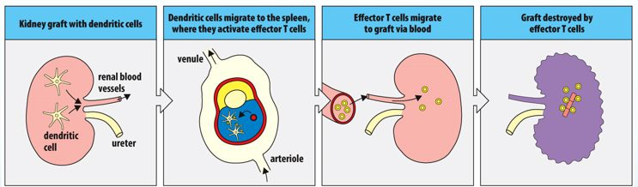
Acute rejection as a round trip. The graft brings its own dendritic cells; they leave for the spleen , activate the recipient’s effector T cells there, and those T cells come back through the blood to destroy the kidney. No antibody appears anywhere in the strip, which is what makes this type IV rather than the antibody-driven hyperacute type II. Source: Lecture 7 Dr. Webster Disorders in Immunity.pptx, Slide 46.
Tissue | Matching requirement | Why
Cornea (first organ successfully transplanted) | Succeeds even without a human leukocyte antigen match | The eye downregulates T cells, macrophages, neutrophils and complement so inflammation cannot impair vision
Liver | Human leukocyte antigens not assessed; ABO blood group is | Architecture and vascularization; hepatocytes carry very little class I and no class II; constant exposure to digestive proteins makes it tolerant
Bone marrow | Most sensitive to human leukocyte antigen discrepancies | Used for genetic disorders and cancers. Sensitivity can cause graft versus host disease: systemic, with skin rash, muscle, liver and gastrointestinal involvement, in about 30% of marrow recipients

Dealing with graft issues: minimize rejection by tissue matching human leukocyte antigens (mixed lymphocyte reaction, tissue typing), and with immunosuppressive drugs — purine analogs, corticosteroids, tacrolimus and cyclosporine, rapamycin (sirolimus).

7.6 · Objective 6 — The etiology of autoimmune conditions
In autoimmunity the immune system has lost tolerance to autoantigens and forms autoantibodies and sensitized T cells against them, destroying self tissue. It involves all hypersensitivity types except type I. There are genetic and gender predispositions: autoimmunities run in families, and women are more likely than men to have them. Disruption can be systemic or organ specific.
Origin | Mechanism | Examples
Sequestered antigen theory | Some tissues are immunologically privileged during embryonic growth; damaged later, they release antigens that are attacked | Central nervous system, lens of the eye, thyroid, testes. Trauma to one eye releases intraocular antigens that activate T cells, which attack both eyes (slide 55)
Molecular mimicry (a normal immune response) | Foreign and self antigens are similar, so the response cross-reacts | Rheumatic fever (cross-reactive strep antigen; antibodies react with heart tissue); Lyme disease arthritis (Borrelia burgdorferi); reactive arthritis (Shigella, Salmonella, Campylobacter); type 1 diabetes (coxsackie virus A and B, echovirus, rubella)
Noninfectious response | Tissue damage without infection | The eye trauma example above
Thymic senescence | The thymus is most active in fetal and early neonatal life, then involutes (replaced by fat). Premature thymic aging is characteristic of young people with autoimmune disorders; decreased output may mean less efficient T cell development and more opportunistic infection, cancer and autoimmunity | The mechanism is unclear

Disease | Target | Result
Graves’ disease | Autoantibodies attach to receptors on thyroxine-secreting follicle cells | More thyroxine — hyperthyroidism
Hashimoto’s thyroiditis | Autoantibodies and T cells destroy follicle cells | Less thyroxine — hypothyroidism
Diabetes mellitus (type 1) | Insulin-producing cells of the pancreas | Reduced insulin
Myasthenia gravis | Autoantibodies bind acetylcholine receptors | Pronounced muscle weakness
Multiple sclerosis | Myelin sheath damaged by T cells and autoantibodies; may follow Epstein-Barr or a retrovirus | Paralyzing neuromuscular disease

Slides 58–60 tabulate further type II, III and IV autoimmune diseases with their autoantigens. They were named in the lecture as charts not to memorize.
Also tested
- Autoimmune predisposition. Women are affected more than men, and autoimmunities also run in families.

7.7 · Objective 7 — Primary versus secondary immunodeficiency
Components of the immune response are absent; deficiencies can involve B cells, T cells, phagocytes and complement.
 | Primary | Secondary
When | Congenital — usually genetic errors | Acquired after birth, from natural or artificial agents
Examples | Agammaglobulinemia (B cell defect, no antibodies → more bacterial infections). DiGeorge syndrome (T cell defect; thymus missing or abnormal → fungal, protozoan, helminth, viral infections). Severe combined immunodeficiency (both lymphocyte limbs missing or defective; no adaptive response). Complement and phagocyte deficiencies | Infection and organic disease — the human immunodeficiency virus targets T helper cells, suppressing immunity overall; chemotherapy or radiation; blood cell cancers

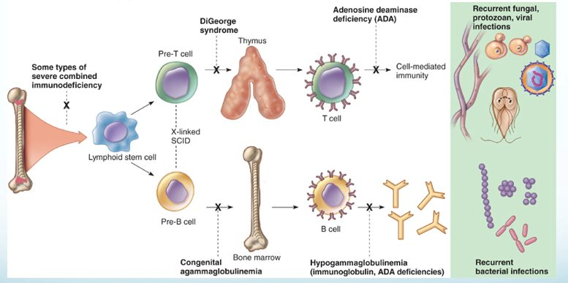
Every primary immunodeficiency is an X on this developmental map, and where the X falls predicts the infections. Block at the stem cell and both limbs fail (severe combined immunodeficiency). Block on the upper T cell limb — no thymus in DiGeorge — and the panel on the right shows fungal, protozoan and viral infections. Block on the lower B cell limb and the result is recurrent bacterial infection. Source: Lecture 7 Dr. Webster Disorders in Immunity.pptx, Slide 64.
Also tested
- Adenosine deaminase deficiency. It causes some types of severe combined immunodeficiency, a congenital, primary defect.

7.8 · Objective 8 — The mechanisms of carcinogenesis
Cancer cells carry genetic alterations that disrupt the normal cell division cycle. Possible causes: errors in mitosis, genetic damage, activation of oncogenes, or retroviruses. Tumors may be benign (nonspreading, self-contained) or malignant (spreading from the tissue of origin to other sites). Immune surveillance keeps cancer “in check.”
Transformation: a cancer arises from a single cell that has accumulated multiple mutations; oncogenes are activated by radiation, chemicals or oncogenic viruses (papillomavirus and cervical carcinoma, hepatitis B virus and liver cancer, among others).
Necessary characteristics of cancer cells
They stimulate their own growth · ignore growth-inhibiting signals · avoid death by apoptosis · develop a blood supply (angiogenesis) · leave their site of origin to invade other tissues (metastasis) · replicate constantly · evade and outrun the immune response

Tumor antigens (more than 1000 identified) | Where found
Tumor specific | On tumor cells, not on normal cells. Derived from viral proteins, mutated cellular proteins or amino acid recombinations
Tumor associated | On tumor cells and on normal cells in smaller amounts

How successful tumors evade immunity. A variant tumor cell can cleave the stress molecule that natural killer and gamma-delta T cells recognize from its surface; the soluble molecule then binds the lymphocytes’ receptor, and the tumor cell escapes killing. Tumors also secrete transforming growth factor beta, suppressing immunity and recruiting regulatory T cells, which make more of it plus interleukin 10 and suppress the CD8 and CD4 type 1 helper cells specific for tumor antigens. The more regulatory T cells in a tumor, the worse the prognosis.
Also tested
- Tumor escape from natural killer cells. When tumor cells cleave a stress molecule that natural killer cells recognize and release it in soluble form, the tumor cell escapes being killed: the soluble molecule binds the killing receptor on natural killer and gamma-delta T cells.

7.9 · Objective 9 — Comparing immunotherapy strategies
Strategy | How it works | Status / use
Immune checkpoint inhibitors | Block checkpoint proteins binding their partner, preventing the “off” signal so T cells keep killing. Do not kill cancer cells directly | Melanoma, some lung cancers
Adoptive cell therapy | Patient’s own cells engineered outside the body and returned | Tumor infiltrating lymphocytes: in development, not approved. CAR-T (chimeric antigen receptor T cells): approved for blood cancers. Chimeric antigen receptor natural killer cells: mostly in trials, including solid tumors
Monoclonal antibodies | Diagnosis and elimination of cancer cells; can carry a chemotherapy drug or radionuclide (anti-CD20 plus radionuclide irradiates malignant B cells; anti-CD30 plus auristatin stops lymphoma cells forming a mitotic spindle) | More than 100 approved by the Food and Drug Administration
Cytokines | Interleukin 2 (aldesleukin): more cytotoxic T and natural killer cells; interferon alpha: activates natural killer and dendritic cells; growth factors: erythropoietin (red cells), interleukin 11 (platelets) | Interleukin 2: metastatic kidney cancer, melanoma. Interferon alpha: melanoma, Kaposi’s sarcoma, several blood cancers
Coley’s toxins | 1890s: bone sarcomas regressed with streptococcal skin infection; mix of killed streptococci and Serratia marcescens | Fell from favor with radiation and chemotherapy
Oncolytic viruses | Infect normal and cancer cells but replicate in and lyse only tumor cells; some natural (mumps), others engineered. Challenge: the immune system may clear them first | A few approved; one in the United States, for melanoma
Cancer vaccines | Prophylactic — prevent the infection (hepatitis B → hepatocarcinoma; papillomavirus → reproductive cancers). Therapeutic — activate immunity against tumor antigens | Bacillus Calmette-Guérin (weakened tuberculosis organism): bladder cancer. Sipuleucel-T: metastatic, castration-resistant prostate cancer

Slide 78 also says granulocyte and granulocyte-macrophage colony-stimulating factors “stimulate growth of T cells.” That is the slide’s wording; no quiz question turns on it.
Source: Lecture 7 — Disorders in Immunity (Dr. Webster), Slides 1–81, and the PAJ 5200 syllabus instructional objectives.
Also tested
- Tumor infiltrating lymphocyte therapy. It is in development, not yet approved; these are cytotoxic T cells expanded to a therapeutic amount.
- Oncolytic viral therapy. The main challenge is that immunity may clear the virus first; only a few are approved, just one in the United States, for melanoma.

8 · Diagnosing Infections
INSTRUCTIONAL OBJECTIVES
- Recall common infectious agents and the diseases that they cause.
- Recall microbial physiology including metabolism, regulation and replication.
- Describe the mechanisms by which an infectious agent causes disease.
- Describe the epidemiology and transmission of infectious agents.
- Discuss common mechanisms of antimicrobial action and resistance.
- Describe antimicrobial treatment strategies.
- Explain preventative interventions employed to prevent infectious diseases.

NOTE
These objectives are the course-wide list, and this lecture is about diagnostic methods. The syllabus (and the deck’s own objective slide) gives this lecture the seven objectives above, but its 57 slides are a survey of how an unknown microbe is identified. So most of the content answers objective 1 — recognizing the agent — and the sections below say plainly where the deck gives an objective only a sentence. Everything hangs on one three-way split: phenotypic, genotypic, immunological. Ask of every technique which of the three it is.

★ PROFESSOR EMPHASIS
★ From the lecture recording — 18 September 2026
45 minutes, both transcripts read and compared; the quotes below appear in both. The recording stops at the break, around slide 43 (“this is a very logical place for us to pause”), so complement fixation, fluorescent antibodies, immunoassays, in vivo testing and viral diagnosis have no audio. The lecture is taught through laboratory anecdote and gives almost no exam steer — the same pattern as this lecturer’s Exam 1 lectures.
What was said | What it means for you
“You don’t have to bog down in a lot of the details… I highlighted some things for you. So blood agar is useful for detecting hemolysis… the take-home message is that the blood agar is useful for detecting hemolysis, especially for pathogenic Gram-positive bacteria like staph aureus or strep pyogenes.” [about minute 18] | The one explicit priority in the recording. Know what each plate is for (slides 17–20) rather than every reagent. Staphylococcus and Streptococcus return in the medically important cocci lecture.
Southern, Northern, Western, Eastern: “Southern was the first, was actually a man’s name, DNA [deoxyribonucleic acid]. RNA [ribonucleic acid] is Northern. Western is protein. And then Eastern is carbohydrates or other epitopes.” [about minute 42] | A memory hook for slides 41–42: only “Southern” is a person (Edwin Southern); the other compass points are a joke on his name.
Genotypic methods for organisms that are hard to grow: Legionella “you have to use live amoeba”; “tuberculosis, leprosy, again, very, very difficult to grow.” [about minute 9] | Matches slide 8 (Mycobacterium, Legionella): culture-free methods earn their cost on slow or difficult organisms.
“This is relevant to Koch’s postulates, but remember, not all organisms will work for Koch’s postulates. So what if the infection turns out to… be viral?” [about minute 27] | Slide 24’s caution: finding an organism is not proof it causes the disease.

One statement to hold loosely: slide 18 and the recording both say chocolate agar is “mainly used for anaerobic culturing,” and the lecturer describes the candle jar that raises carbon dioxide. Learn it as the slide states it for this exam; it is flagged for review rather than silently changed.

8.1 · Objective 1 — Identifying the agent: the three categories
Category | What it examines | Needs culture?
Phenotypic | Observable microscopic and macroscopic characteristics (phenotype = “the physical expression of genes”): morphology, physiology and biochemistry, chemical analysis, sensitivity to antimicrobial drugs | Usually — so may take longer
Genotypic | Genetic makeup: deoxyribonucleic acid and ribonucleic acid sequence analysis, restriction fragment length polymorphism, specific gene sequencing to build phylogenies, electrophoresis | Usually not
Immunological | Serology — antibody-antigen reactions: agglutination, precipitation, immunoelectrophoresis, complement fixation, immunofluorescence, immunoassays, in vivo allergy testing | May or may not — but always exploits antigen-antibody specificity

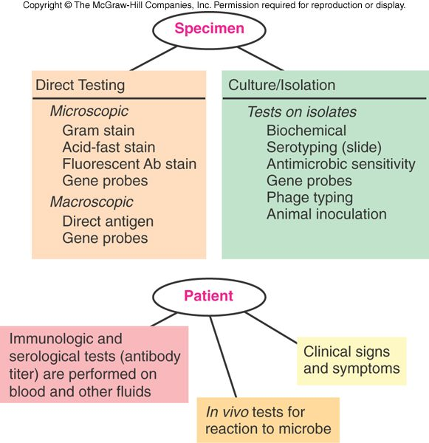
The two routes a specimen can take. Direct testing (left) looks at the specimen itself — stains, direct antigen, gene probes — and is fast. Culture and isolation (right) grows the organism first and then tests the isolate, which is slower but opens biochemical tests, serotyping and sensitivity testing. Notice gene probes appear on both sides, and that the patient contributes too: antibody titers, in vivo tests and the clinical picture. Copyright © The McGraw-Hill Companies. Source: PAJ5200.Diagnosing Infections-2.pptx, Slide 14.
Results come in two categories, presumptive or confirmatory. Immune tests are generally easier (and more accurate) than testing for the microbe itself: the rapid strep test takes 10–15 minutes — but you need a hypothesis first to choose the test (fever, sore throat and pus pockets on the tonsils suggest strep throat).
Also tested
- Rapid immunological tests. You need a hypothesis to target it: fever, sore throat and pus-pockets on the tonsils lead you to suspect strep throat, and only then does the rapid test answer the question.

8.2 · Objective 1 — Genotypic methods
Genotypic methods assess the organism’s genetic makeup and need no culture — valuable for slow-growing Mycobacterium and hard-to-grow Legionella. Precise, automated methods give quick results, and faster, more accurate diagnosis means proper treatment begins in a timely manner.
Technique | Key facts
deoxyribonucleic acid probe hybridization / restriction fragment length polymorphism (“deoxyribonucleic acid fingerprinting”) | Probes complementary to a microbe’s specific sequences bind. Restriction enzymes cut deoxyribonucleic acid into fragments whose lengths differ between organisms
Polymerase chain reaction | A thermal cycler amplifies specific pieces of deoxyribonucleic acid or ribonucleic acid; basic concept invented by Kary Mullis and colleagues. Guanine plus cytosine content helps taxonomic determination, not necessarily a specific identification
Ribosomal ribonucleic acid sequencing | Compares base sequences to establish relationships: 16S ribosomal ribonucleic acid genes for bacteria (prokaryotes), 18S for eukaryotes; builds phylogenetic trees (slide 29: the oral microflora)

Also tested
- Genotypic methods. Their major practical advantage is that culture is not necessary. This matters most for slow-growing organisms such as Mycobacterium and difficult ones such as Legionella, since the delay of culture is avoided entirely.

8.3 · Objective 1 — Serology, agglutination and precipitation
Serology is in vitro diagnostic testing of serum. Antibodies are extremely specific, so the methods are very sensitive. Visible results: precipitates, color changes, or released radioactivity. Tests identify antibody and measure how much is present — the titer, often reported in binding antibody units. A known antigen can test a patient’s serum (serological diagnosis), or known antibody can identify an unknown microbe (serotyping).
 | Agglutination | Precipitation
Antigen | Whole-cell or insoluble | Soluble, made insoluble by antibody
What you see | Large visible clumps that sink | A visible precipitate; needs a gel or liquid matrix
Sensitivity | Generally more sensitive than precipitation; run on a card or slide | Very sensitive
Uses | Blood typing; rapid syphilis diagnosis; cold agglutinins for mycoplasmas; Weil-Felix test for rickettsial disease; latex agglutination for pregnancy; color-changing rapid strep tests are a modified agglutination technique | Tube precipitation; Ouchterlony double diffusion in agar gel; immunoelectrophoresis identifies which antibody class (immunoglobulin G, M and so on) binds antigen in serum

Also tested
- Serological test reactions. They can produce precipitates, color change, radioactivity, and report not only presence but amount, the titre, often given in binding antibody units.
- Agglutination tests. The Weil-Felix test for rickettsial diseases uses agglutination, alongside blood typing, rapid syphilis diagnosis, cold agglutinin for mycoplasmas and the latex-agglutination pregnancy test.
- Serology. Serology is in vitro diagnostic testing of serum samples. Because antibodies have extreme specificity for antigens, these are very sensitive methods.
- Agglutination testing. It detects whole-cell or insoluble antigens, which antibody cross-links into complexes that settle out as large visible clumps, generally sinking to the bottom of the container.
- Agglutination clumps. They settle to the bottom of the container, which makes the result visible without instrumentation and lets the test run on a card or slide.

8.4 · Objective 1 — Blots, complement fixation, fluorescence, immunoassays, in vivo tests and viruses
Blot | Detects | Notes
Southern (about 1975) | Specific deoxyribonucleic acid sequences | The original, invented by Edwin Southern
Northern (about 1977) | ribonucleic acid (gene expression) | Oncogenes; transplant rejection
Western (about 1981) | Proteins | Electrophoresis then an immunoassay; bands where antibody binds. Second test used to verify human immunodeficiency virus status; also bovine spongiform encephalopathy, Lyme disease, hepatitis B
Eastern (about 1982) | Proteins, lipids, carbohydrate epitopes | Post-translational products

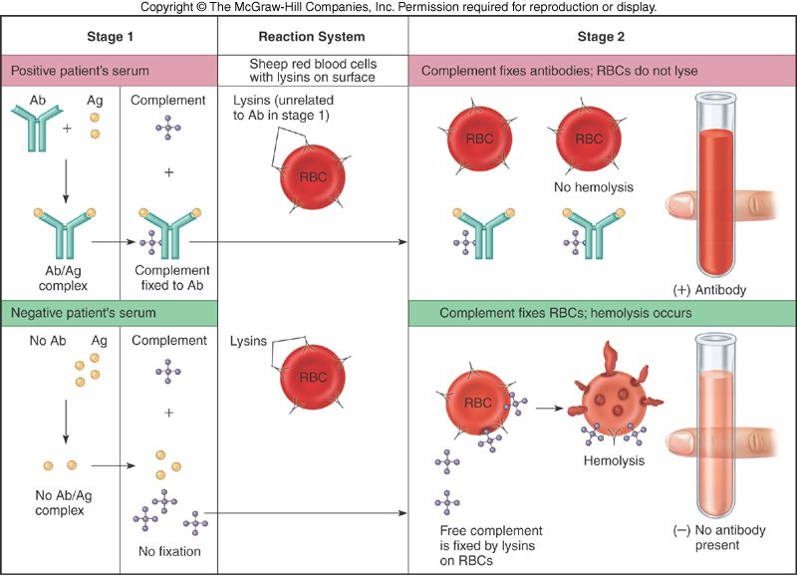
The counter-intuitive test, drawn so the logic shows. In the top row the patient’s antibody meets antigen and uses up (“fixes”) the complement, so none is left to burst the sheep red cells: an intact red tube means antibody is present . In the bottom row there is no antibody, the complement stays free, the lysins on the sheep cells use it, and the tube turns clear with hemolysis: negative . Lysis is the negative result. Copyright © The McGraw-Hill Companies. Source: PAJ5200.Diagnosing Infections-2.pptx, Slide 46.
Complement fixation (“lysin-mediated hemolysis”, now largely replaced by enzyme-linked immunosorbent assay) uses four components: antigen, antibody (lysin), complement and sensitized sheep red cells. Fixed complement → no hemolysis → the patient’s serum is positive. Unfixed complement → hemolysis → negative.
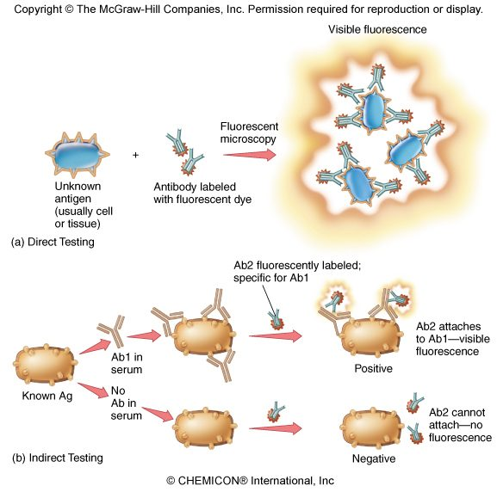
Direct versus indirect, which is the whole distinction. Direct (top): a fluorescent antibody binds the unknown organism or tissue itself, so it identifies the antigen . Indirect (bottom): the patient’s serum is laid on a known antigen and a second, fluorescent anti-antibody shows whether the serum’s antibody stuck, so it detects the patient’s antibody . No antibody in the serum, nothing for the second antibody to bind, no glow. Copyright © The McGraw-Hill Companies. Source: PAJ5200.Diagnosing Infections-2.pptx, Slide 48.
Method | Key facts
Fluorescent antibody testing | A monoclonal antibody labeled with a fluorescent dye shows cells or aggregates, by direct or indirect methods
Immunoassays | Extremely sensitive — detect trace amounts of antigen or antibody. Radioimmunoassay: labeled with radioactive isotopes. Enzyme-linked immunosorbent assay: an enzyme-antibody complex produces a colored product (chromogen) when its substrate is added; run in 96-well plates
In vivo testing | Antigen introduced into the body to detect antibody or sensitivity: tuberculin skin test, allergy testing
Viruses | Special difficulty: they are not cells and need a specific host cell to replicate, so they are labor intensive to culture. Rapid point-of-care tests may use antigen-antibody reactions

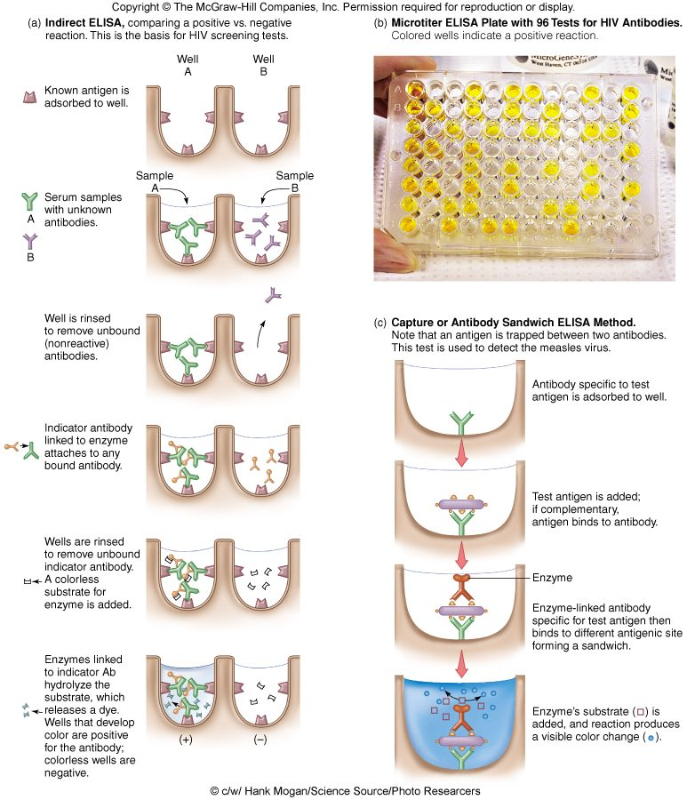
Two designs, one readout. The indirect assay (left) coats the well with known antigen to catch a patient’s antibody — the basis of human immunodeficiency virus screening, and the yellow wells in the plate are the positives. The capture or sandwich assay (right) coats the well with antibody to catch an antigen between two antibodies, used here for measles virus. In both, color appears only where the enzyme-linked antibody stayed bound. Copyright © The McGraw-Hill Companies. Source: PAJ5200.Diagnosing Infections-2.pptx, Slide 51.
Also tested
- Northern blot. It is used to study gene expression by detecting RNA, and is useful in the study of oncogenes and in rejection of transplanted organs.
- Western blot. It is used to verify HIV status as a second test, and has also been used definitively for bovine spongiform encephalopathy, Lyme disease and hepatitis B.
- Original electrophoretic blotting. It was invented by Edwin Southern, around 1975, to detect specific DNA sequences in DNA samples; the Northern, Western and Eastern blots all take their names from his.
- In vivo testing. Unlike serology, antigen is introduced directly into the body to determine the presence or absence of antibodies; the tuberculin skin test and allergy testing are the named examples.

8.5 · Objective 2 — Microbial physiology in the laboratory
Phenotypic identification reads the organism’s physiology and metabolism.
Method | What it looks at
Microscopic morphology | Fresh or stained organisms: cell shape, size, stain reaction (Gram, flagellar, acid-fast), cell structures. Immediate direct examination also uses direct fluorescent antibody and direct antigen testing
Macroscopic morphology | Colony appearance on test plates: texture, size, shape, pigment, growth requirements
Physiological / biochemical | Presence or absence of particular enzymes or metabolic pathways — product formed means the enzyme is present
Chemical analysis | Specific chemical composition: cell wall peptides, cell membrane lipids

Common test or medium | What it shows
Carbohydrate fermentation, amino acid utilization, hydrolysis of gelatin, starch or lipids, catalase, oxidase, coagulase, hemolysins | The common biochemical tests
Blood agar | Detects hemolytic activity
Chocolate agar | “Mainly used for anaerobic culturing” (the slide’s wording)
Mannitol salts agar | Selects for salt tolerance and differentiates by the pH change of mannitol fermentation
Simmons citrate | Citrate utilization; bromthymol blue turns blue as pH rises
Triple sugar iron slant | Several pH changes observable on one slant
Urea broth | Urea hydrolysis raises pH; hot pink = urease present
Rapid test strips (API 20E) | Many biochemical tests on one strip
Bacteriophage typing; animal inoculation | Phage susceptibility; growth in an animal (for example Mycobacterium leprae)

Replication, the last part of this objective, appears once: viruses cannot be cultured like bacteria because they replicate only inside a specific host cell (slide 54).
Also tested
- Simmons citrate medium. A blue color indicates a rising pH, reported by the bromthymol blue indicator, because citrate utilization drives the pH up.
- Macroscopic morphology. It assesses colony appearance on culture media, including texture, size, shape, pigment and growth requirements, all observed with the naked eye rather than under the microscope.
- Immediate direct examination. The Gram stain and acid-fast stain are named for it, together with direct fluorescent antibody and direct antigen testing, which report before anything has been cultured.

8.6 · Objective 3 — Is the organism causing the disease?
The deck does not teach disease mechanisms in this lecture. What it does say is the diagnostic form of the question: whether the microbe recovered is actually causing the disease, or whether you are simply detecting normal flora — the reasoning of Koch’s postulates, traditional and molecular (slide 24). Some virulence enzymes are themselves the test: hemolysins on blood agar and coagulase appear among the common tests (slide 17).

8.7 · Objective 4 — Specimens, handling and transmission risk
The deck’s epidemiology here is the specimen itself. All specimens should be considered potentially infectious. Results depend on collection, handling, transport and storage; some specimens need a preservative or fixative, others cooling, heating or other special treatment. Aseptic procedures and universal precautions (gloves, face shields, masks) mitigate but do not eliminate the risk of transmission. Slides 11–12 show collection sites and methods (nasopharynx, throat, sputum, blood, cerebrospinal fluid, urine by clean catch or catheter, feces, skin, genital swabs); a specimen then goes to direct testing or to cultivation, isolation and identification.
Also tested
- Phenotypic methods. They may take longer to reach a diagnosis because the microbes must be cultured: observable characteristics, biochemical reactions and sensitivity testing all depend on having grown the organism first.

8.8 · Objectives 5 & 6 — Antimicrobial sensitivity testing and treatment strategy
The Kirby-Bauer disk-diffusion test gives which drug is effective and at what dose, and may indicate which combinations can be used. Larger zones of inhibition mean a more effective agent. Minimum inhibitory concentration strips add the concentration needed. For treatment strategy the deck’s point is speed: faster, more accurate (genotypic) diagnosis means proper treatment can begin in a timely manner. Mechanisms of action and resistance themselves were Lecture 2’s subject.
Also tested
- Zone of inhibition. A larger zone indicates a more effective agent; minimum inhibitory concentration strips give the same information as a concentration, the lowest level that stops growth.

8.9 · Objective 7 — Preventative interventions
The deck offers one: aseptic procedure and universal precautions during specimen collection and handling, which mitigate but do not eliminate transmission (slide 10). Vaccination and other prevention are not in this deck.
Source: Diagnosing Infections (PAJ5200.Diagnosing Infections-2.pptx), Slides 1–57, and the PAJ 5200 syllabus instructional objectives.

